Lab – Doubly LinkedBag

The original LinkedBag class stored its items in a linked chain of nodes. Each node in the chain contained a single “link,” or one reference to the node following it in the chain.


next
data

This type of linked chain is sometimes called a “singly linked chain.” We could instead include a second reference in each node that points backward to the node in the chain before it:

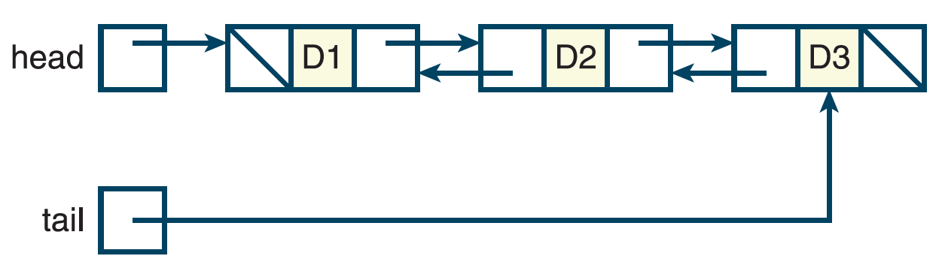
prev
data
next

This type of linked chain is sometimes called a “doubly linked chain.” Often in addition to the head reference, which links to the first node of the chain, they will include a tail reference linking to the last node in the chain.

Notice that the first node in the chain has no “prev” reference value since no node comes before it in the chain.

In this lab you’ll create a modified version of the class LinkedBag that maintains its items in a double linked chain.

Step 1

First, we must add a 2nd reference variable to the Node class that will point backward to the previous node in the chain.

Add the variable prev to the Node class. Add a 3rd parameter to the constructor to allow a value to be passed in for prev. Default the parameter to None.

Step 2

Next, add the variable tail to the LinkedBag and the corresponding parameter defaulted to None. This variable will refer to the final node in the linked chain.

Step 3

Next, update LinkedBag’s clear() to appropriately reset tail when the list is cleared.

Step 4

As with the original LinkedBag, there is no particular ordering to the items in the bag. So, we will still add each new item as the new head node. Since every new node we add will be the new head node, the new node will always have a prev of None.

But, now that we are using a doubly linked chain, we’ll need to deal with 2 scenarios: when we add to an empty chain, and when we do not.

When adding to an empty chain, we just add the new node as the head node of the chain as in the original version, but tail needs to be updated to refer to the new head node. That creates this scenario:

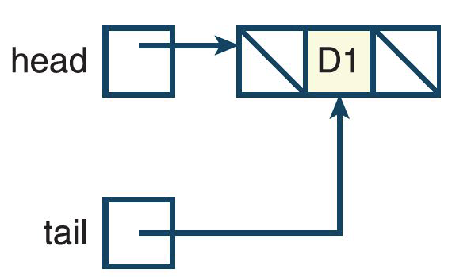

After that, when we add another node to the chain the tail reference will just “float” along continuing to point to last node.

On the other hand, when we’re adding a node to a non-empty chain, we first need to update the prev reference for the current head node to point backwards to the new node.
This will need to be updated to refer to the new node which is about to added to the front of the chain.



So, after creating the new node to be added to the chain, you’ll need to:
- Update prev in the current head node to refer to the new node. The syntax for reaching this is: self.head.prev
- Update head to refer to the new node.

Update add() to handle adding a new node to an empty and non-empty chain appropriately. Note you can tell whether the chain is empty or not by testing to see if head is None. Don’t forget to increment size!

Step 5

remove() will stay largely the same, but we need to update the prev references correctly when a node is removed.

First, look at the branch that handles the head node being removed. Note head is already pointing to the correct node. After the old head node is removed, if the chain is not empty, set the new head node’s prev to None (it’s the first node in the chain, it has no prev).


Removing this node doesn’t change tail. But it does change the prev of the node after it.

Else we’ve just removed the only node in the chain, so tail also needs to be set to None.
Removing this node requires a change to tail.



Next, look at the branch that handles a non-head node being removed. curNode is the node to be removed, and prevNode is the node in the chain before the node to be removed. If curNode is not the final node in the chain (you can tell by looking at curNode.next), then we need to update the node following curNode’s prev reference (that’s curNode.next.prev) to refer to the node in before curNode (that’s prevNode). We also need to update prevNode’s next to refer to the node after curNode in the chain.

Removing this node doesn’t change tail. But it does change next of the node in front of it and prev of the node after it.



Else, curNode is the final node in the chain and we’re removing it, so tail needs to refer to prevNode (the node in front of curNode) because it will now be the last node in the chain. Now set tail’s next to None (because it is now the last node in the chain).

Removing this node changes tail to be the node before it.



Step 6

Last, let’s update __str__() to step backwards through the chain from the tail rather than forward through the chain from the head.

So, rather than starting the traversal with curNode set to self.head, begin with curNode set to self.tail. The “building” of bagString can remain unchanged, but instead of stepping forward through the chain by setting curNode to curNode.next, step backwards by setting it to curNode.prev.

Step 7

That’s it! Test your code and submit by the due date.

